BIOL 4970

Summer 2018

Determination of an ACTH Standard Curve through ELISA Analysis to Determine the Concentration of an Unknown Sample

Mehar Anand

Dr. Sheba MohanKumar

Mehar Anand

Dr. Sheba MohanKumar

11011 Estates Circle

Department of Veterinary Sciences

Alpharetta, GA 30022 and Diagnostic Imaging

mka76957@uga.edu shebamk@uga.edu

(678) 650- 9543 (517) 290-1903

1. **Objective**

The objective of our current research is to generate the most data-fitting standard curve between varying concentrations of ACTH and their absorbance values. This standard curve will serve as the best model to calculate and quantify ACTH concentration in future serum samples that will be tested. The ACTH concentration is determined by comparing the assay response of a sample to that of a standard whose concentration is known by using the standard curve (Natarajan et al., 2008).

1. **Abstract**

The Enzyme Linked Immunosorbent Assay, or ELISA, is extensively used to calculate and quantify the adrenocorticotropic hormone, or ACTH, concentration within samples (Selman et al., 2011). This concentration is analyzed for determining the stress levels of laboratory animals worked on. The ACTH concentration of these samples is determined through the usage of a standard curve by comparing the sample’s unknown concentration of ACTH to the known concentration of ACTH given by the standard curve (Astrid et al., 2010). In analytical chemistry, a standard curve is a quantitative method in determining the concentration of a substance of unknown samples by comparing them to a known concentration (Astrid et al., 2010). To determine which standard curve will serve as the best model for calculating and quantifying the ACTH concentration, the R-squared value, the coefficient of determination, is analyzed to determine how far away the dependent variables are from the predicted or best fit line. This is known as a linear regression analysis. If the standard curve is linear, an R-squared value of close to 1 or 100% will explain most of the variability of the response data around the mean, in this experiment (Selman et al., 2011). This ELISA data also is interpreted in order to indicate whether the ACTH antigen is present within a sample and can compare the relative levels of ACTH antigen in samples, as absorbance varies directly with the ACTH antigen concentration. The data ultimately allows researchers to detect deficiencies and diseases by investigating the binding between the antigen concentration and the antibody concentration (Natarajan et al., 2008).

1. **Introduction**

Adrenocorticotropic hormone, or ACTH, is secreted by the anterior pituitary gland. This antigen is a significant component of the hypothalamic-pituitary-adrenal axis and serves as a response to biological stress within animals (Natarajan et al., 2008). This secretion is triggered by the corticotropic releasing hormone, or CRH, released by the hypothalamus, which stimulates the adrenal glands to release corticosteroids, prominently cortisol. But, it is also responsible in the production of sex hormones, such as testosterone, estrogen, progesterone, and aldosterone, which regulate blood pressure and kidney function. ACTH has been shown to limit cholesterol by lowering the lipid levels in the blood (Natarajan et al., 2008). It is essential to study ACTH concentration, as a halt in ACTH secretion may lead to metabolic disturbances and adrenal insufficiency. ACTH is involved in a negative feedback loop, in which chronic stress may induce the adrenal cortex to pump out ACTH hormones until the body’s circadian rhythm exhausts and leads to adrenal burnout. As a result, the body lacks to respond to injury, fatigue, low blood pressure, and blood abnormalities (Natarajan et al., 2008). ACTH deficiency may also induce troubled sleep, hyperarousal, and insomnia, as an increase in stress leads to a decrease in sleep.

In this research, our project focuses on generating a standard curve between varying concentrations of ACTH and their absorbance values, that will serve as the best model to calculate and quantify ACTH concentration in serum samples being tested in the future. By utilizing the best standard curve to measure the concentration of ACTH in serum samples, we reduce much of the background noise and variation that may be present in our data. This allows for the measure of the ACTH concentration to be accurate when comparing and quantifying the data. This standard curve also functions as the basis in detecting the value of unknown ACTH concentration in serum samples to be tested on later, as the value of the unknown concentration of ACTH present within a sample cannot be determined without comparison to known values found on a standard curve. The objective of our research was to develop a standard curve and validate an enzyme-linked immunosorbent assay for measuring ACTH in samples of stressed and non-stressed rats in the future. The generation of the best data fitted curve will lead ultimately to the detection of ACTH deficiency and other diseases present within animals. Researchers may use this data to manipulate the feedback loop initiated by the secretion of ACTH, potentially developing solutions and medications to allow for the recovery from stress related health concerns in animals, and in people (Natarajan et al. 2008). This calibration curve will produce an equation that will aid in determining the unknown concentrations of future serum samples.

1. **Materials and Methods**

Purified ACTH was reconstituted with mL nanopore water. The solution was stored in 1 mg/mL aliquots in -80°C, as the ACTH is hygroscopic, or tends to absorb moisture from the environment. ACTH also degrades rapidly over time, so there were strict conditions kept, preventing the hormone from denaturing. Two stocks, Stock A and Stock B, were created using these aliquots. For Stock A, 1 microliter of the 1 mg/mL solution was diluted in 1000 microliters of coating buffer. For Stock B, 4 microliters of Stock A were diluted in 1000 microliters of coating buffer, which now became a 4 ng/mL stock solution. We used a homemade antibody, Rabbit 70-4 which bled in 1984, as our primary antibody. We used a Donkey-anti-Rabbit antibody as our secondary antibody in the experiment. These antibodies were utilized within the experiment as the antibody-antigen binding rate is higher than antibodies from other animals.

This assay was performed over a course of three days. To begin, we utilized a high-binding, 96 well plate. We added 100 microliters of coating buffer into each well. Afterwards, we added 100 microliters of Stock B, which comprised of the 4 ng/mL of ACTH stock solution, into the first column, and then serial diluted by ten-fold. This resulted in our team using 200 pg/100 ul as our standards for the experiment. The last column was left as a blank, so no antigen was pipetted into the wells. We then covered the plate in parafilm and incubated the plate in 37° C for 1 hour and 4° C overnight afterwards. The next day, we removed the parafilm and dumped the antigen from the plate and pat drying the plate onto paper towels. We added 300 microliters of blocking solution to each well of the plate and left it at room temperature for 1 hour after covering the plate in parafilm. We then unwrapped the parafilm, dumped the blocking solution, and washed the plate three times with PBS. After pat drying, we added our primary antibody, which was pipetted through various concentrations. Each set of rows, Rows A and B, Rows C and D, Rows E and F, and Rows G an H, served as varying measures to determine which concentration of ACTH would result in the best data fitting trendline and result in the best model t measure ACTH concentration from future serum samples. We diluted our primary antibody in coating buffer to a 1:1000 ratio for rows A and B, 1:5000 for rows C and D, 1:10000 for rows E and F, and 1:20000 for rows G and H of the plate. We then covered our plate in parafilm and incubated the plate for 1 hour in 37° C. Afterwards, we left the plate in 4° C overnight. This ensured a stable environment for the ACTH and the antibody to bind in. The next day, we removed the parafilm and we dumped the primary antibody from the plate, pat dried, and washed the plate with PBST three times. We added 100 microliters of our secondary antibody to the plate. We added the secondary antibody in coating buffer in a 1:3000 ratio to all wells. We wrapped the plate using parafilm and let the plate sit at room temperature for 1 hour. We unwrapped the parafilm off the plate, dumped the secondary antibody from the plate, and washed the plate with PBST three times. After pat drying, we added 100 microliters of Enhanced K-Blue TMB Substrate into each well. After allowing the plate to develop and observing a gradation of color, we added 100 microliters of sulfuric acid to each well of the plate to stop the reaction. We then placed the plate into the ELISA Reader to detect the absorbance of each well.

**V. Results**

**Table 1: Absorbance Values from ELISA Results**

Rows B, D, F, and H serve as duplicates for Rows A, C, E, and G, respectively. 450 indicates the wavelength used by the ELISA reader to detect absorbance for each of the well in the plate. The gradation of color indicates the serial dilution was completed successfully, as the standards for well after another showed a decrease in antigen concentration.

**Absorbance Values**

|  |  |  |  |  |  |  |  |  |  |  |  |  |  |
| --- | --- | --- | --- | --- | --- | --- | --- | --- | --- | --- | --- | --- | --- |
|  | 1 | 2 | 3 | 4 | 5 | 6 | 7 | 8 | 9 | 10 | 11 | 12 |  |
| A | 2.763 | 2.702 | 2.465 | 2.284 | 2.273 | 2.331 | 2.081 | 1.766 | 1.793 | 1.776 | 1.519 | 1.64 | 450 |
| B | 2.725 | 2.424 | 2.386 | 2.146 | 2.287 | 2.208 | 2.169 | 1.895 | 1.862 | 1.77 | 1.558 | 1.538 | 450 |
| C | 1.485 | 1.102 | 0.972 | 0.865 | 0.812 | 0.851 | 0.665 | 0.666 | 0.735 | 0.671 | 0.635 | 0.615 | 450 |
| D | 1.574 | 1.116 | 0.941 | 0.902 | 0.894 | 1.136 | 0.824 | 0.868 | 0.733 | 0.622 | 0.562 | 0.658 | 450 |
| E | 0.549 | 0.418 | 0.351 | 0.372 | 0.39 | 0.484 | 0.398 | 0.327 | 0.338 | 0.331 | 0.318 | 0.334 | 450 |
| F | 0.637 | 0.656 | 0.405 | 0.441 | 0.405 | 0.401 | 0.409 | 0.375 | 0.351 | 0.309 | 0.337 | 0.338 | 450 |
| G | 0.463 | 0.374 | 0.328 | 0.315 | 0.421 | 0.431 | 0.317 | 0.375 | 0.337 | 0.262 | 0.263 | 0.323 | 450 |
| H | 0.563 | 0.4 | 0.438 | 0.342 | 0.338 | 0.385 | 0.317 | 0.321 | 0.268 | 0.298 | 0.259 | 0.325 | 450 |

**Table 2. ELISA Analysis: Coefficient of Determination**

The coefficient of determination, or the R-squared value, was measured using the average absorbance values and concentration values. The absorbance values were determined by the ELISA reader.

|  |  |
| --- | --- |
| **Rows** | **Coefficient of Determination (R-squared Value)** |
| **A and B** | **0.7715** |
| **C and D** | **0.9299** |
| **E and F** | **0.8908** |
| **G and H** | **0.8212** |

**Table 3: Binomial Equation for Rows C and D**

The slope and y-intercept required for the binomial equation was found by the coefficient of determination using a function in Excel.

|  |  |  |  |
| --- | --- | --- | --- |
| **Slope** | **Y-Intercept** | **Coefficient of Determination** | **Y=MX+B** |
| **216.815049** | **-155.678199** | **0.9299** | **Y=216.815049X + (-155.678199)** |

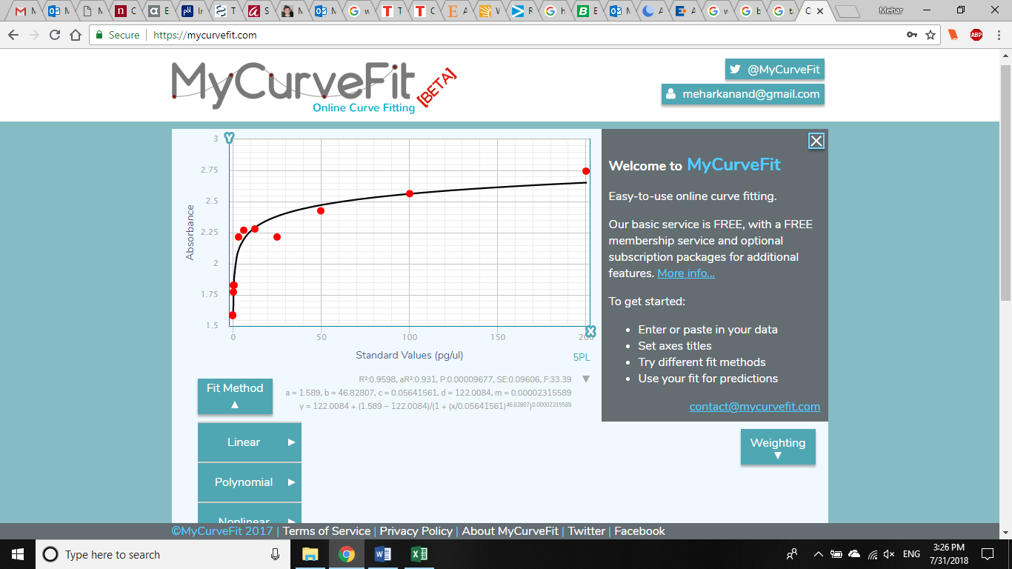

**Figure 1: Best Fit Trendline for Rows A and B Based on Average Absorbance Values and Standard Values**

The line of best fit was fitted using absorbance values and concentration values. The absorbance values were determined by the ELISA reader. The best fit line was produced using a program in Microsoft Excel to determine the coefficient of determination, the slope, and the y-intercept.

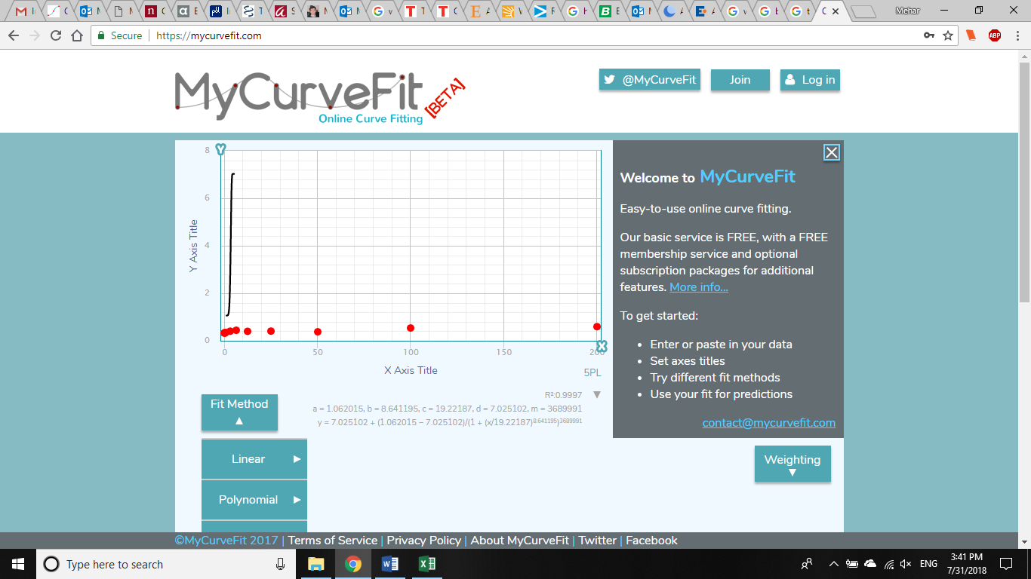

**Figure 2: Best Fit Trendline for Rows E and F Based on Average Absorbance Values and Standard Values**

The line of best fit was fitted using absorbance values and concentration values. The absorbance values were determined by the ELISA reader. The best fit line was produced using a program in Microsoft Excel to determine the coefficient of determination, the slope, and the y-intercept.

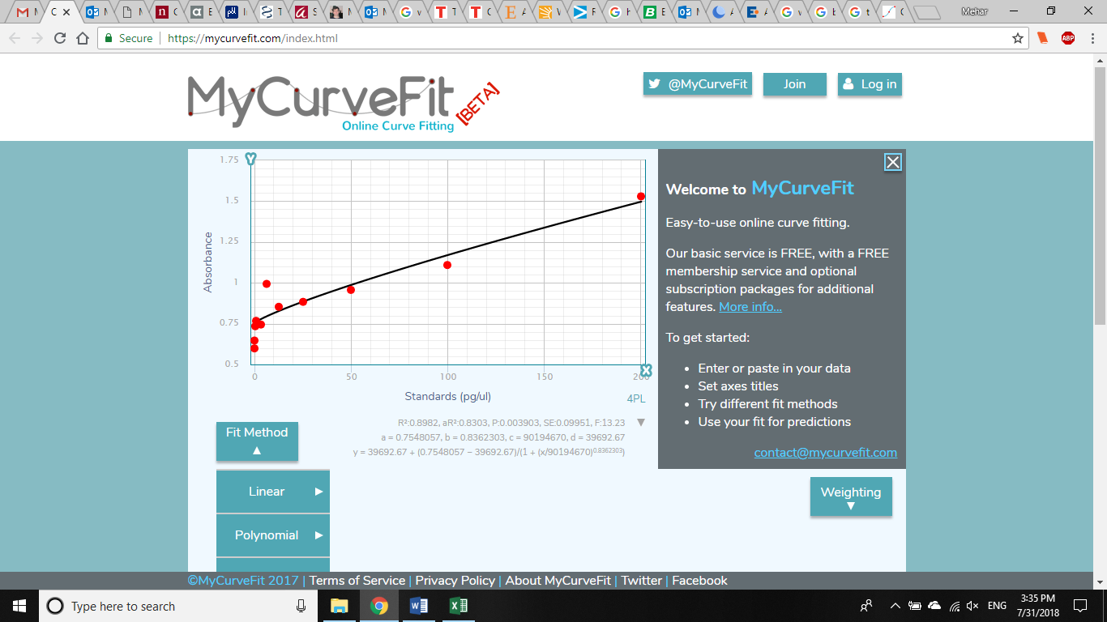

**Figure 3: Best Fit Trendline for Rows C and D Based on Average Absorbance Values and Standard Values**

The line of best fit was fitted using absorbance values and concentration values. The absorbance values were determined by the ELISA reader. The best fit line was produced using a program in Microsoft Excel to determine the coefficient of determination, the slope, and the y-intercept.

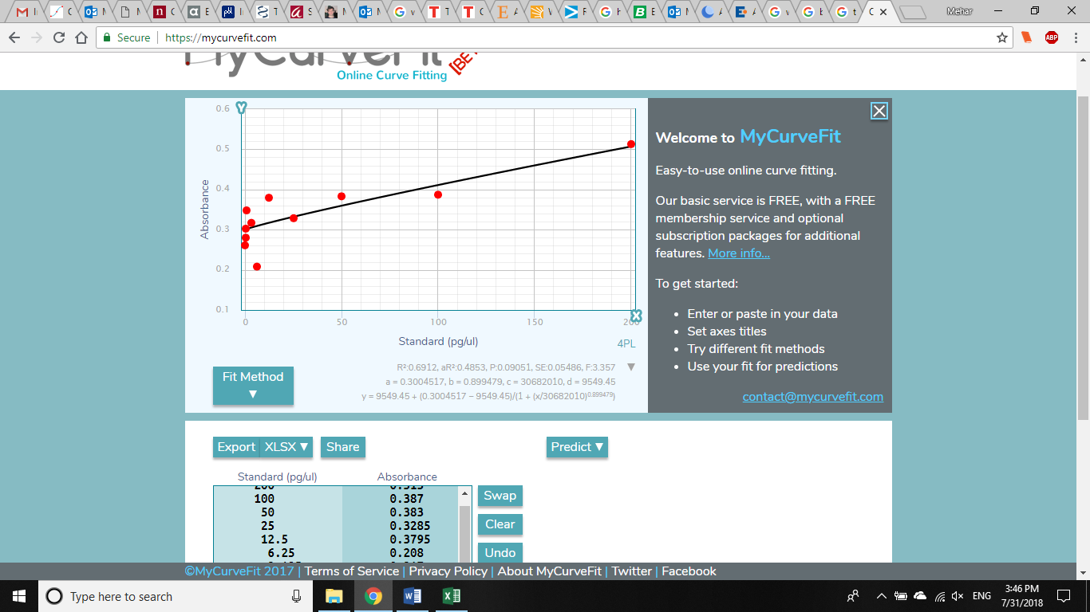

**Figure 4: Best Fit Trendline for Rows G and H Based on Average Absorbance Values and Standard Values**

The line of best fit was fitted using absorbance values and concentration values. The absorbance values were determined by the ELISA reader. The best fit line was produced using a program in Microsoft Excel to determine the coefficient of determination, the slope, and the y-intercept.

Table 1 displays the individual absorbance values for each well. These values were found using the ELISA Reader. The gradation in color represents the gradient in concentration of ACTH antigen throughout the wells. Table 2 displays the coefficient of determination for Rows A and B, Rows C and D, Rows E and F, and Rows G and H. They are 0.7715, 0.8908, 0.9299, and 0.8212, respectively. These values were calculated by computing the average absorbance values, from the individual absorbance values, and correlating the average values with the standard values, found in Table 1. Figure 1, Figure 2, and Figure 4 graphs display a sigmoidal shape, indicating the data points are reaching towards a peak, but there is a large source of error occurring within the experiment. According to Table 2, Rows C and D have the highest R-squared value, 0.9299. Figure 3 graph for Rows C and D shows a trendline that fits most of the data points, while the trendlines for the other graphs, Figures 1, 2, and 4, are sigmoidal or do not fit many of the data points. One can conclude that Figure 3 has the best fit data line among its graph because an almost linear pattern is displayed. The R-squared value of 0.9299 is the closest to 1, explaining the variability of the response data around the mean. This linear trend also shows how data points on the lower concentrations of the standard curve are compressed, hence making that the most accurate range, or the area most likely to achieve the required R-squared value. One can conclude that Rows C and D, pipetted with a 1:5000 ratio of diluted homemade antibody resulted in the most linear R-squared value, 0.9299. This 1:5000 ratio of diluted antibody using 200 pg/ul standards from a serial dilution serves as the best model to calculate and quantify the ACTH concentration in future serum samples. Figure 3 shows how average absorbance of each duplicate and the standard values are closely related. Although the other R-squared values, determined by the absorbance values from Table 1 and obtained from Table 2, 0.7715, 0.8908, and 0.8212 are relatively high compared to an R-squared value of 0.5, they will not serve as the best model to calculate and quantify the ACTH concentration in future serum samples. From Table 3, the slope and the y-intercept were calculated by using the coefficient of determination for Rows C and D. The slope determined is 216.815049 and the y-intercept determined is -155.678199. This formulates the binomial equation to be y=216.815049x – 155.678199, from Table 3.

1. **Discussion**

The graphs for each section of rows display either a sigmoidal relationship between concentration of ACTH and antibody binding and absorbance or a linear relationship between concentration of ACTH and antibody binding. A sigmoidal curve follows a curved shape and can indicate a logarithmic or logistic scale. The sigmoidal curve shows that the data is leading towards a peak but replicates of the experiment are needed and more research needs to be done. This is due to data points moving away from the best fit line due to errors in the experiment, too much variation and variability, background noise, or improper conditions in which the experiment was carried out. A linear relationship between the concentration of ACTH and the absorbance values serve as better indicators of a successful experiment. A linear relationship demonstrates that there is a small amount of error that may have been random. This relationship also indicated that conditions were favorable for the ACTH and the antibody to bind in, creating a strong standard that can be relied upon when determining the concentration of an unknown sample.

For Figure 1, or Rows A and B, one can observe that the antibody ratio of 1:1000 solution pipetted into the wells may have been too concentrated, leading to absorbance values that were too high and less stable. These values resulted in an R-squared value of 0.7715 which is not optimal to use as a model for determining concentration values from the standard curve, as there may be more noise, background, or instability when measuring the concentration of ACTH from samples in the future, from Table 2. This also indicates that the conditions in which the ACTH and antibody bonded in may be unfavorable. For Figure 2, or Rows E and F, one can observe that the antibody ratio of 1:10000 solution pipetted into the wells may have been less concentrated, leading to absorbance values that were lower but somewhat stable. These values resulted in an R-squared value of 0.8908, which is not the most optimal to use as a model for determining concentration values from the standard curve, from Table 2. For Figure 4, or Rows G and H, one can observe that the antibody ratio of 1:20000 solution pipetted into the wells may have been the least concentrated, leading to absorbance values that were too low and less stable. These values resulted in an R-squared value of 0.8212, found in Table 2, which is not optimal to use as a model for determining concentration values from the standard curve.

One can conclude that the ratio of 1:5000 is the most optimal to serve as a model to calculate and quantify the ACTH concentration in future serum samples being tested. The coefficient of determination for this ratio, 0.9299, from Table 2, demonstrates the most linear graph and best fit data point among the trendline of the graph, observed in Figure 3. This ratio serves as the basis for unknown ACTH concentrations of samples to be found. The importance of the coefficient of determination has been highlighted in this experiment, as it places certainty in the predictive value of the regression line (Selman et al., 2011). This strong coefficient of determination also serves a stronger purpose here in that it explains why the binding between the antibody and the ACTH antigen is prominent. When the antibody binds with the ACTH antigen, this induces a cascade of proteins, called a complement (Inbal et al., 2013). When a complement occurs, a partnership forms with the antibody after reacting with the ACTH antigen, seeking out to eliminate any foreign invaders and restore the health of the body (Inbal et al., 2013). This relationship will be demonstrated when observing and analyzing the bond between the ACTH antigen and the antibody in future serum samples. In Table 3, the slope and y-intercept were determined since this set of rows resulted in a strong linear R-squared value. The slope is significant to this experiment because it indicates a measurement of sensitivity within the experiment, or how much a signal changes due to a change in concentration. A steeper line indicates more sensitivity and a more defined range of concentrations, as demonstrated by Figure 3, or Rows C and D (Gold et al., 2010). The slope and the y-intercept formulated an equation, y = 216.815049x – 155.678199. This equation defines how the variable in the x variable explains the variation in the y variable. This equation will be used in the future to determine the unknown concentration of ACTH within a serum sample by calculating the unknown concentration and comparing it to the standards among the standard curve (Gold et al., 2010). This is significant as multiple samples with known properties will measured and graphed, which then allows the same properties to be determined for unknown samples by interpolation on the graph (Astrid et al., 2010).

This experiment served as a crucial foundational step in performing larger scale experiments in the future. Now that our team has found an accessible and highly favorable ratio to determine ACTH concentrations, we will collect serum samples from stressed and non-stressed rats and determine what concentration of ACTH is secreted by the pituitary gland. We will then compare these determined values with the standard values among the graph for Rows C and D, since it has the highest coefficient of determination, a linear trend, and a best fit line that settles among most of the data points. This is significant for future research because we can impact the healthcare industry, the pharmacological industry, and the scientific research industry directly. The concentration of ACTH determined will aid in distinguishing which factors lead to the secretion of hormones as an adrenal response and how severe one’s health may be due to the level of secretion. Pharmacists may develop supplements that limit adrenal exhaust. This can potentially change the public’s mindset and methods regarding the recovery process of any stress-related incidents and illnesses. We also can study the complexity of the hypothalamic-pituitary-adrenal axis and its systematic relation to the rest of the human body. This axis directly impacts our behavior, our emotions, our physical health, our competence, and our motor functions. By studying the levels of ACTH, we may be able to manipulate the axis, a major component of the brain, through genetic engineering, medication, or even constant home practice to limit the number of illnesses that arise due to external factors, an imbalance of chemicals in the body, and stress.

There were many limitations to this experiment. This experiment must be precise in every step that is taken throughout the procedure, as there is a high risk of detachment or dislodging of the antibody. Due to this potential risk, the optimal binding between the antibody and the ACTH antigen may have experienced discrepancies, such as during times of washing with PBS and PBST. While washing, the solution may have hit the antibody directly, instead of the side of the plate, dislodging the antibody. This may have resulted in a less optimal R-squared value. Another limitation was that the standard ACTH antigen solution was not stored in -80°C until after aliquoting the substance. This may have led the hormone to degrade, alternating its strength and structure. This may have hindered the results, leading to a weaker R-squared value.

1. **Conclusion**

The objective of our research was to develop a standard curve and validate an enzyme-linked immunosorbent assay for measuring ACTH in samples of stressed and non-stressed rats in the future. The generation of the best data fitted curve will lead ultimately to the detection of ACTH deficiency and other diseases present within animals. Researchers may use this data to manipulate the feedback loop initiated by the secretion of ACTH, potentially developing solutions and medications to allow for the recovery from stress related health concerns in animals, and in people.

1. **References**

## Astrid, S., Hommel, G., Blettner, M. 2010. Linear Regression Analysis. *Journal of Deutsches Ärzteblatt International.* 107.

# Gold, J., Law, C., Connolly, P., Bennur, S. 2010. Relationships Between the Threshold and Slope of Psychometric and Neurometric Functions During Perceptual Learning: Implications for Neuronal Pooling. *Journal of Neurophysiology*.154.

# Inbal, S., Kunik, V., Ofran, Y. 2013. The Structural Basis of Antibody -Antigen Recognition. *Frontiers in Immunology*.302

# Natarajan, S., Remick, D. 2008.The ELISA Standard Save: Calculation of sample concentrations in assays with a failed standard curve. *Journal of immunological Methods.* 336.

# Selman, L., Henrikson, J., Waters, P.L., Holmskov, T.J., Jorgsen, C., Nielson, K. 2011. An enzyme-linked immunosorbent assay (ELISA) for quantification of human collectin 11. *Journal of Immunological Methods.* 10.